1. Docker version

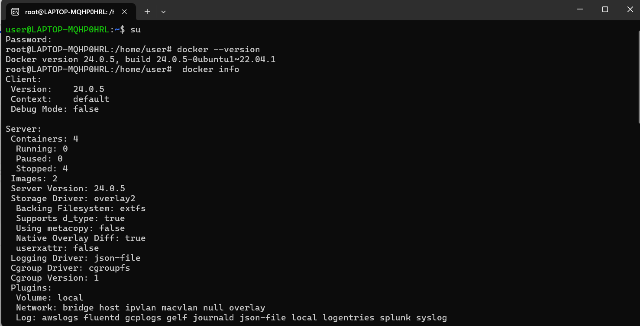

1. Docker run hello world

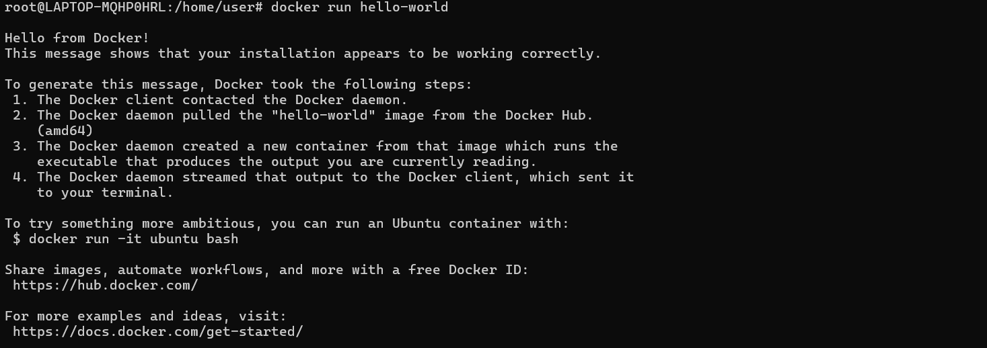

1. Docker image ls



1. docker container ls --all

